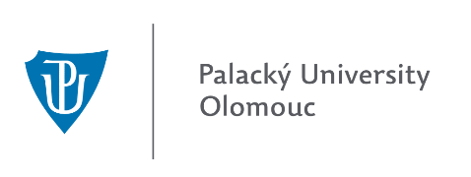
INTERNATIONAL WEEK
AT THE FACULTY OF EDUCATION, PALACKÝ UNIVERSITY, OLOMOUC
First Call

Dear partners, dear colleagues, dear friends,
This is just a brief note to let you know that we are going to organize the 1st International Week at the Faculty of Education in Olomouc between 5th and 9th October 2015. We would like to cordially invite you to attend this event.
The aim of the event is to bring various international partners together and share their ideas, experiences, make new partnerships, increase students´ mobility, promote various universities and their study possibilities to Palacký University students etc.; this all during many formal and informal meetings and gatherings.
We will be glad to welcome both teachers who will use their Erasmus teaching mobility, as well as administrative staff dealing with international affairs who can come within Erasmus training mobility. However, it is not necessary to use the Erasmus+ framework. The event is open for all, even for those who are not our official partners yet.
There will be a registration fee (€ 80,-) for the International Week which covers coffee breaks, 3 lunches, all day excursion, administrative issues etc.
We do hope you will be interested in participating in our international week. We feel that we, as the university and faculty, have many things to offer, and on top of that, Olomouc is a charming city and you will certainly fall in love with it. So that we can get an idea about programme scheduling please send us preliminary application form as soon as possible, but by 31st May 2015 at the latest.
With best wishes

Vojtech Regec
Vice-Dean for International Relations

Olomouc, 2nd March 2015

